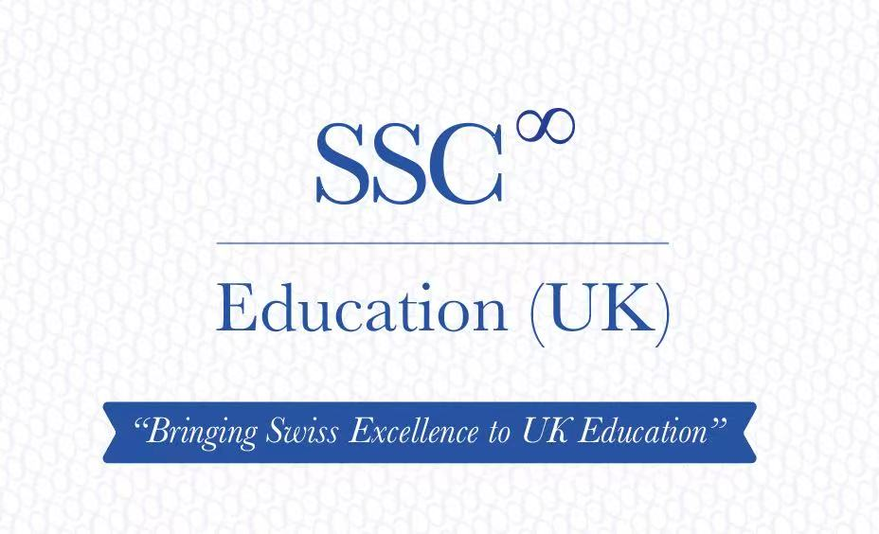

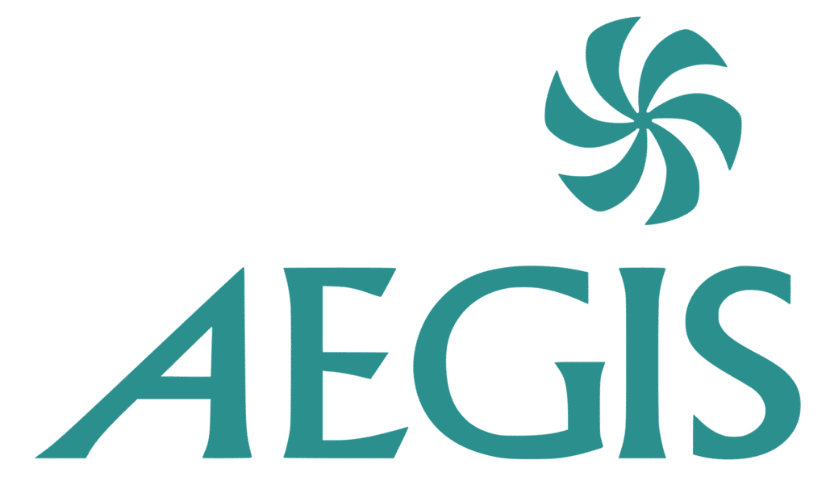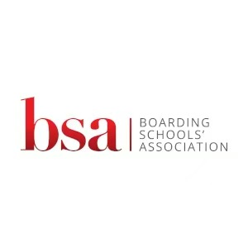

Picture

Picture

Contents

Welcome from our CEO
Dear Parents and Students,
It is my great pleasure to welcome you to Swiss School Consulting’s new U.K. Guardianship service. For over 30 years, Swiss School Consulting has supported families in making informed educational choices and helping students thrive in Switzerland’s most respected boarding schools. We are delighted to expand our services by offering dedicated guardianship support for international students studying in the United Kingdom.
We understand that choosing to study abroad is both an exciting opportunity and a significant commitment for students and their families. Our guardianship service has been designed to provide reassurance, guidance, and practical support throughout a student’s educational journey in the U.K. As your appointed guardian, we will act as a trusted local point of contact, working closely with you, your parents, and your school to ensure that you are safe, supported, and able to make the most of your educational experience. Our responsibilities include maintaining regular communication with families, assisting with travel arrangements, providing emergency support when needed, and helping students navigate life away from home.
At Swiss School Consulting, we believe that successful guardianship goes beyond meeting school requirements. Our goal is to foster confidence, wellbeing, and personal growth while ensuring that every student feels cared for and connected during their time in the United Kingdom. We are committed to delivering a personalised, responsive, and professional service that reflects the high standards and family-centred values that have always guided our work.
Whether you are preparing for your first term at a U.K. school or continuing your educational journey, we look forward to supporting you every step of the way. Thank you for placing your trust in Swiss School Consulting. We are honoured to be part of your educational experience and look forward to getting to know you and your family.

With warm regards,

Serge Gay 
Founder & Director
Swiss School Consulting

The Swiss Touch – Unmatched Care and support.

Here are five reasons parents and students chose SSC

- Dedicated Personal Support

Every student and family has a named guardian who knows them personally. This allows for stronger relationships, faster communication, and more tailored support.
From our homemade cake service delivered to our students on their birthday to our dedicated Chinese, Russian, German, French and Spanish speaking parent liaison officers, our personal touch is unmatched in the guardianship world.

2. Rapid Emergency Response

We maintain clear procedures and local coverage to ensure students receive prompt assistance whenever issues arise, whether related to health, travel, accommodation, or school matters.

3. Safeguarding-First Approach

Student welfare is at the center of everything we do. Our guardians are trained in safeguarding, maintain regular contact with students, and work closely with schools and parents to identify and address concerns early.
We work with Safehire.ai, whose patented technology, background checks using AI combined with human analyst review, identify potential safeguarding, reputational, and security risks that may not be found through traditional DBS checks.

4. Transparent Communication with Parents

Parents receive regular updates and have direct access to key contacts. We provide clear reporting, timely notifications, and responsive support so families remain informed and involved.

5. Quality Over Quantity

By limiting the number of students assigned to each guardian, we can provide a more personalised experience, stronger oversight, and a higher level of care than high-volume providers.

Taking Safeguarding to the next level

In addition to undertaking enhanced DBS checks, our host families and guardians undertake AI -assisted background screening and recruitment risk assessments.

SSC works with Safehire.ai, whose patented technology, background checks using AI combined with human analyst review, identify potential safeguarding, reputational, and security risks that may not be found through DBS checks.

We search publicly available information and intelligence sources, including parts of the deep and dark web.

(picture of dark web)

The technology produces reports highlighting potential risk indicators that may not appear in enhanced DBS or reference checks.

The cutting edge screening can identify indicators related to:

* Child safeguarding risks
* Extremist or radicalised affiliations
* Hate speech and harmful online behaviour
* Insider-risk concerns
* Other digital-reputation and security issues

(picture of dark web)

Our UK partner - Edinburgh Guardian Angels

SSC is a proud partner of Edinburgh Guardian Angels, a leading AEGIS Gold standard Guardianship company.
Edinburgh Guardian Angels combine safeguarding accreditation, experienced leadership, high-quality host families, and comprehensive student support. It’s particularly valued by parents of international students who want peace of mind while their children study in the UK.

Academic Internships @ ETH Zurich

An academic internship is a structured, short-term, research-based work experience placement that combines practical learning in a professional setting with clear academic goals.

Our students have the opportunity work with leading academics in a variety of fields at Switzerland’s leading university – ETH Zurich. ETH Zurich is ranked in the top ten universities globally and is world-renowned institution known for its academic rigour and research excellence, it is celebrated in particular for its strength in STEM subjects (Science, Technology, Engineering, and Mathematics).

Academic Internships allow students to:

1. Apply theoretical knowledge: translating concepts acquired in coursework into real-life scenarios.

2. Gain practical experience: gain skills and industry exposure to specific professional fields.

3. Enhance academic research: the internship will be tied to research objectives or projects relevant to a student’s intended area of study.

4. Enhance university applications: learn the requirements of a successful personal statement and gain the upper hand at interviews.

Our students have provided us with truly positive testimonials, highlighting our care for the continued academic and personal development of our clients. The opportunity to work with ETH PhD students is a unique experience, rarely available to high school students. We have received particularly positive feedback with respect to helping students hone their academic writing and referencing skills, learning to master computer programming languages, and working as a part of a professional team.

Career Mentorship

Top-tier employers such as Goldman Sachs received 315,000 applications for only 2,600 internships. That’s an acceptance rate of just 0.8%.

At SSC we help our students get a head start by with our Careers Mentorship and Professional Development programmes:

Commercial Internships
For Year 12 or Year 13 students hoping to cultivate their commercial acumen and build practical skills, we offer a 3-week consulting internship in which students will get to help real businesses solve challenging problems (ranging from market expansions to competitive analysis); students will be critically assessed in groups or individually. Throughout the programme, they will cultivate problem-solving, teamwork, and communication skills (to name a few) in a professional setting, under the guidance and mentorship of senior consultants working at prestigious consultancies such as McKinsey and OC&C.

Gap-Year Placement
For Year 13 students planning to take a structured and purposeful gap year before university, we offer a tailored Gap-Year Placement programme designed to give them direct exposure to the corporate world. Students will be matched with placements across sectors such as Banking, Consulting, Law, and Big Tech. These placements provide hands-on experience in high-performing teams, allowing students to build professional skills, expand their networks, and gain real insight into what a future career in these fields entails. Alongside the placement itself, students receive pre-placement training, mid-point check-ins, and post-placement debriefs with industry mentors to help them reflect on their development and position themselves for future academic and career success. For many students, this experience becomes a key differentiator in university applications and early job interviews alike.

1-1 Careers Mentorship
For ambitious sixth formers and current university students, we will connect them with corporate professionals working across Central Banking, Investment Banking, Strategy Consulting, Corporate Law, and Big Tech at prestigious firms with the likes of Bank of England, McKinsey, EY, Amazon, Freshfields, and BNP Paribas. On a 1-to-1 basis, mentors will provide customised blueprints and tailored advice on an ongoing basis to help students achieve their aspirations, both academically and professionally.

Subject Tutoring and Academic Support

1. Academic Excellence:
ETH Zurich is ranked in the top ten universities globally and is world-renowned institution known for its academic rigour and research excellence, it is celebrated in particular for its strength in STEM subjects (Science, Technology, Engineering, and Mathematics). A tutor from ETH can offer high-quality support, valuable insight, and specialised expertise far beyond the standards of A level or IB.

2. Research Opportunities:

Tutors from ETH may be involved in cutting-edge research, providing students with exposure to the latest developments and methodologies in their field.

3. High Standards:

Students tutored by an ETH student are always encouraged to meet high academic standards, which helps them to develop strong study habits and critical thinking skills. Our tutors lead by example to give students a head start in both their academic and professional lives.

US Scholarship and US University Consulting

For students aspiring to study at top US universities such as Harvard, Stanford, MIT, and Yale, we work with a number of specialist US education consultants that provide end-to-end guidance on navigating the highly selective US admissions process.
With acceptance rates often below 5% at leading institutions, standing out requires more than just academic excellence.
Our consultants support students in crafting compelling personal statements, preparing for SAT/ACT tests, building distinctive extracurricular profiles, and securing strong teacher recommendations.
Students will also receive mentorship from successful applicants and admissions experts with extensive experience in Ivy League schools and other elite US institutions.
The goal is simple: to maximise students' chances of admission - and scholarship - at the world’s most competitive universities.

Medical training UCAT/ Medical Interview
Preparing for your University Clinical Aptitude Test (UCAT) can be monotonous and is often a hurdle in Medical school applications.

We provide:
1. Personalised guidance and SMART goals: like all of our mentors, your UCAT tutor will adapt to your learning style and expectations. They will help you identify challenges and put together a rigorous training plan with effective techniques that have been tried and tested.

2. Expert knowledge: our tutors have been through the process themselves, they are able to advise students on the test format and provide useful hints and tips.

3. Continuous practice and strategic feedback: students will have access to a multitude of mock exams.

4. Time management strategies: our tutors focus on effective time management techniques to help students maximise the number of points available to them.

5. A confidence boosting and motivational approach: exams and interviews can be stressful, our tutors focus on helping students develop strategies to reduce anxiety under pressure and perform well on test day.

Medical Interview Training

???Overseas Medical Work Experience
Having international medical work experience can be hugely beneficial to your medical school application.

These experiences allow you to demonstrate the following skills:

1. Global perspectives: it highlights your ability to adapt to different healthcare systems and cultural contexts.

2. Diverse experiences: you will gain exposure to various medical practices, patient populations, and challenges.

3. Resilience and adaptability: working in unfamiliar environments can showcase your ability to cope with stress and uncertainty.

4. Enhanced understanding: you develop a deeper appreciation for global health issues and disparities.

5. The competitive edge: international experience can make your application stand out, demonstrating your initiative and commitment to medicine.

Mathematics for AI training @ETH

Psychology and well being of our students

Post High School Support

International students often need support in several areas because they are adapting not only to university-level study but also to a new country, culture, and social environment.

International students typically benefit from a combination of academic, language, social, emotional, practical, financial, and career support. Effective support helps them succeed academically while also feeling confident, included, and able to thrive in their new environment.

Where needed, SSC can extend guardianship and support to its students well into university.

Rental Guarantor Service

Following strong demand from former students, starting in 2026, SSC will now offer its students in the UK a rental guarantee services.

Many international students face difficulties securing private accommodation because they:

Have no UK credit history.
Do not have a UK-based guarantor.
Cannot provide references from previous UK landlords.
May be unfamiliar with local rental processes and tenancy agreements.

Previously, without access to a guarantor, many students were asked to pay several months—or even a full year’s rent—in advance, creating a significant financial barrier. This is now illegal, following the Renter’s Rights Bill, introduced in May 2026.

Our guarantor support can therefore play a crucial role in ensuring our international students have fair access to safe and affordable housing.

